Task 1: VPC – Networking & Subnetting
- Create a new VPC with CIDR 10.0.0.0/16.
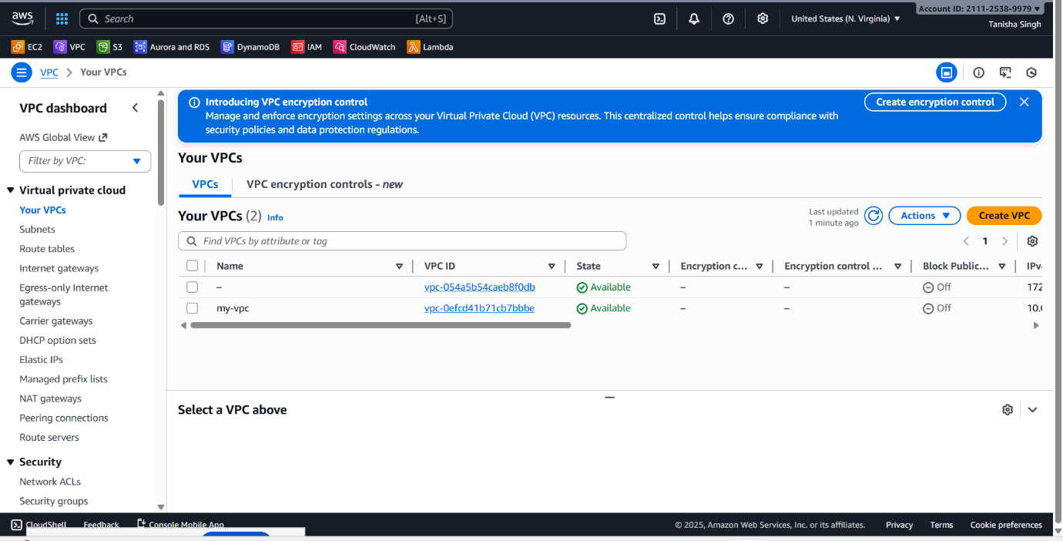
- Create Public Subnet 1 with CIDR 10.0.1.0/24.
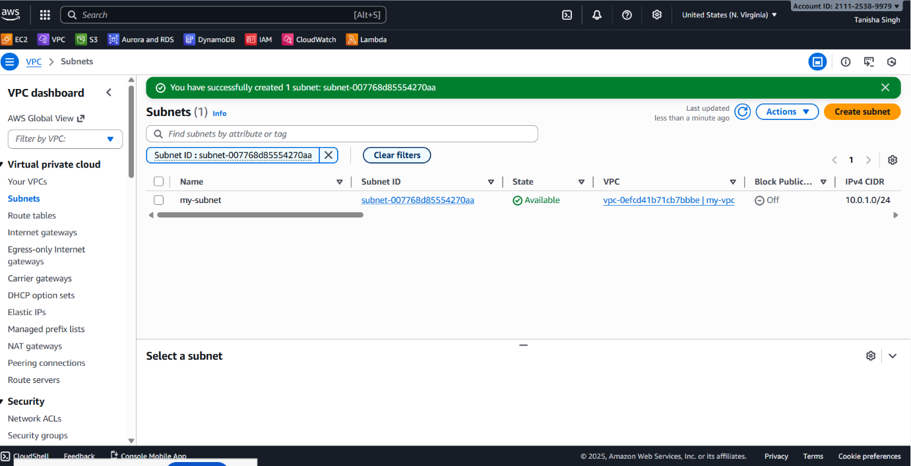
- Create an Internet Gateway and attach it to the VPC.
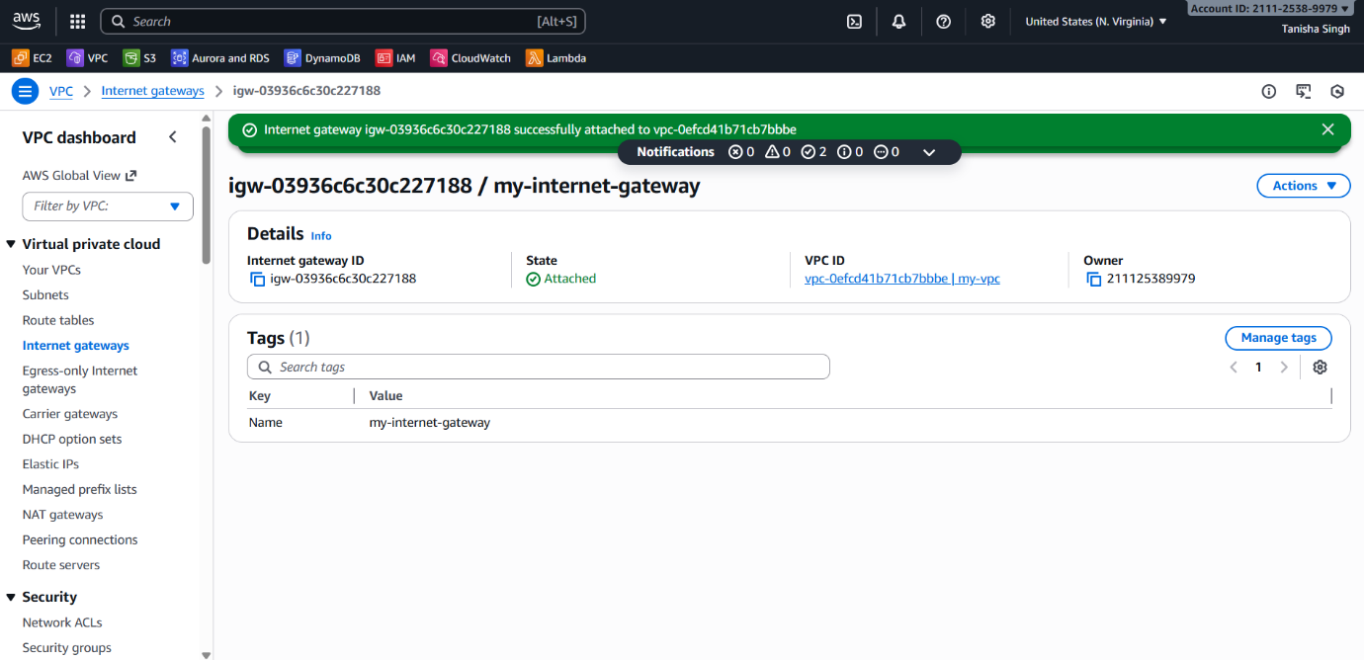
- Create Public Route Table and add IGW route (0.0.0.0/0).
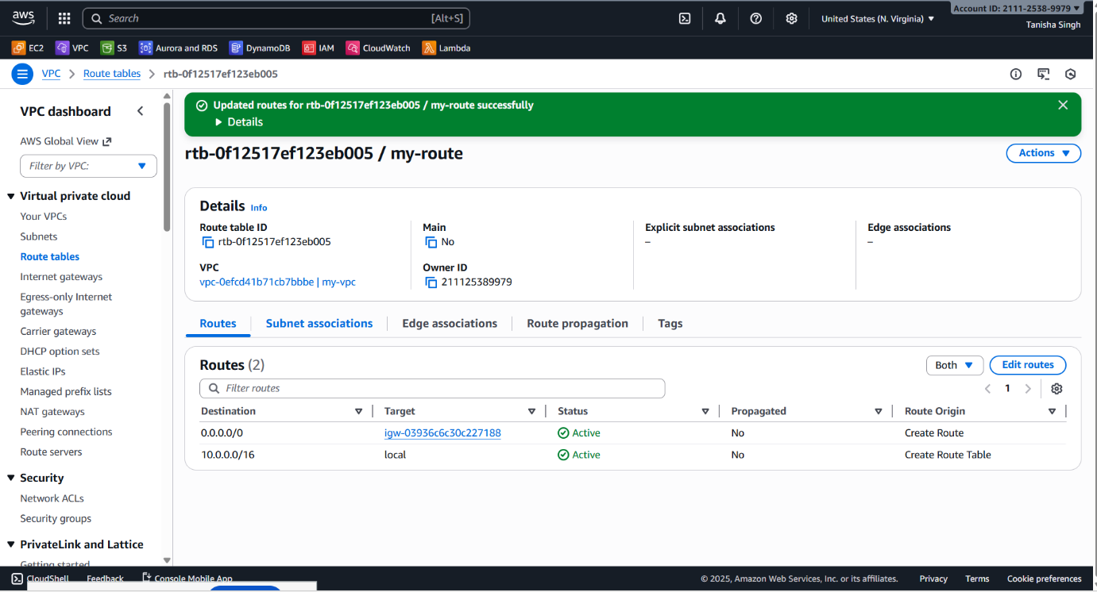
- Associate public subnets with public route table and private subnets with private route table.

